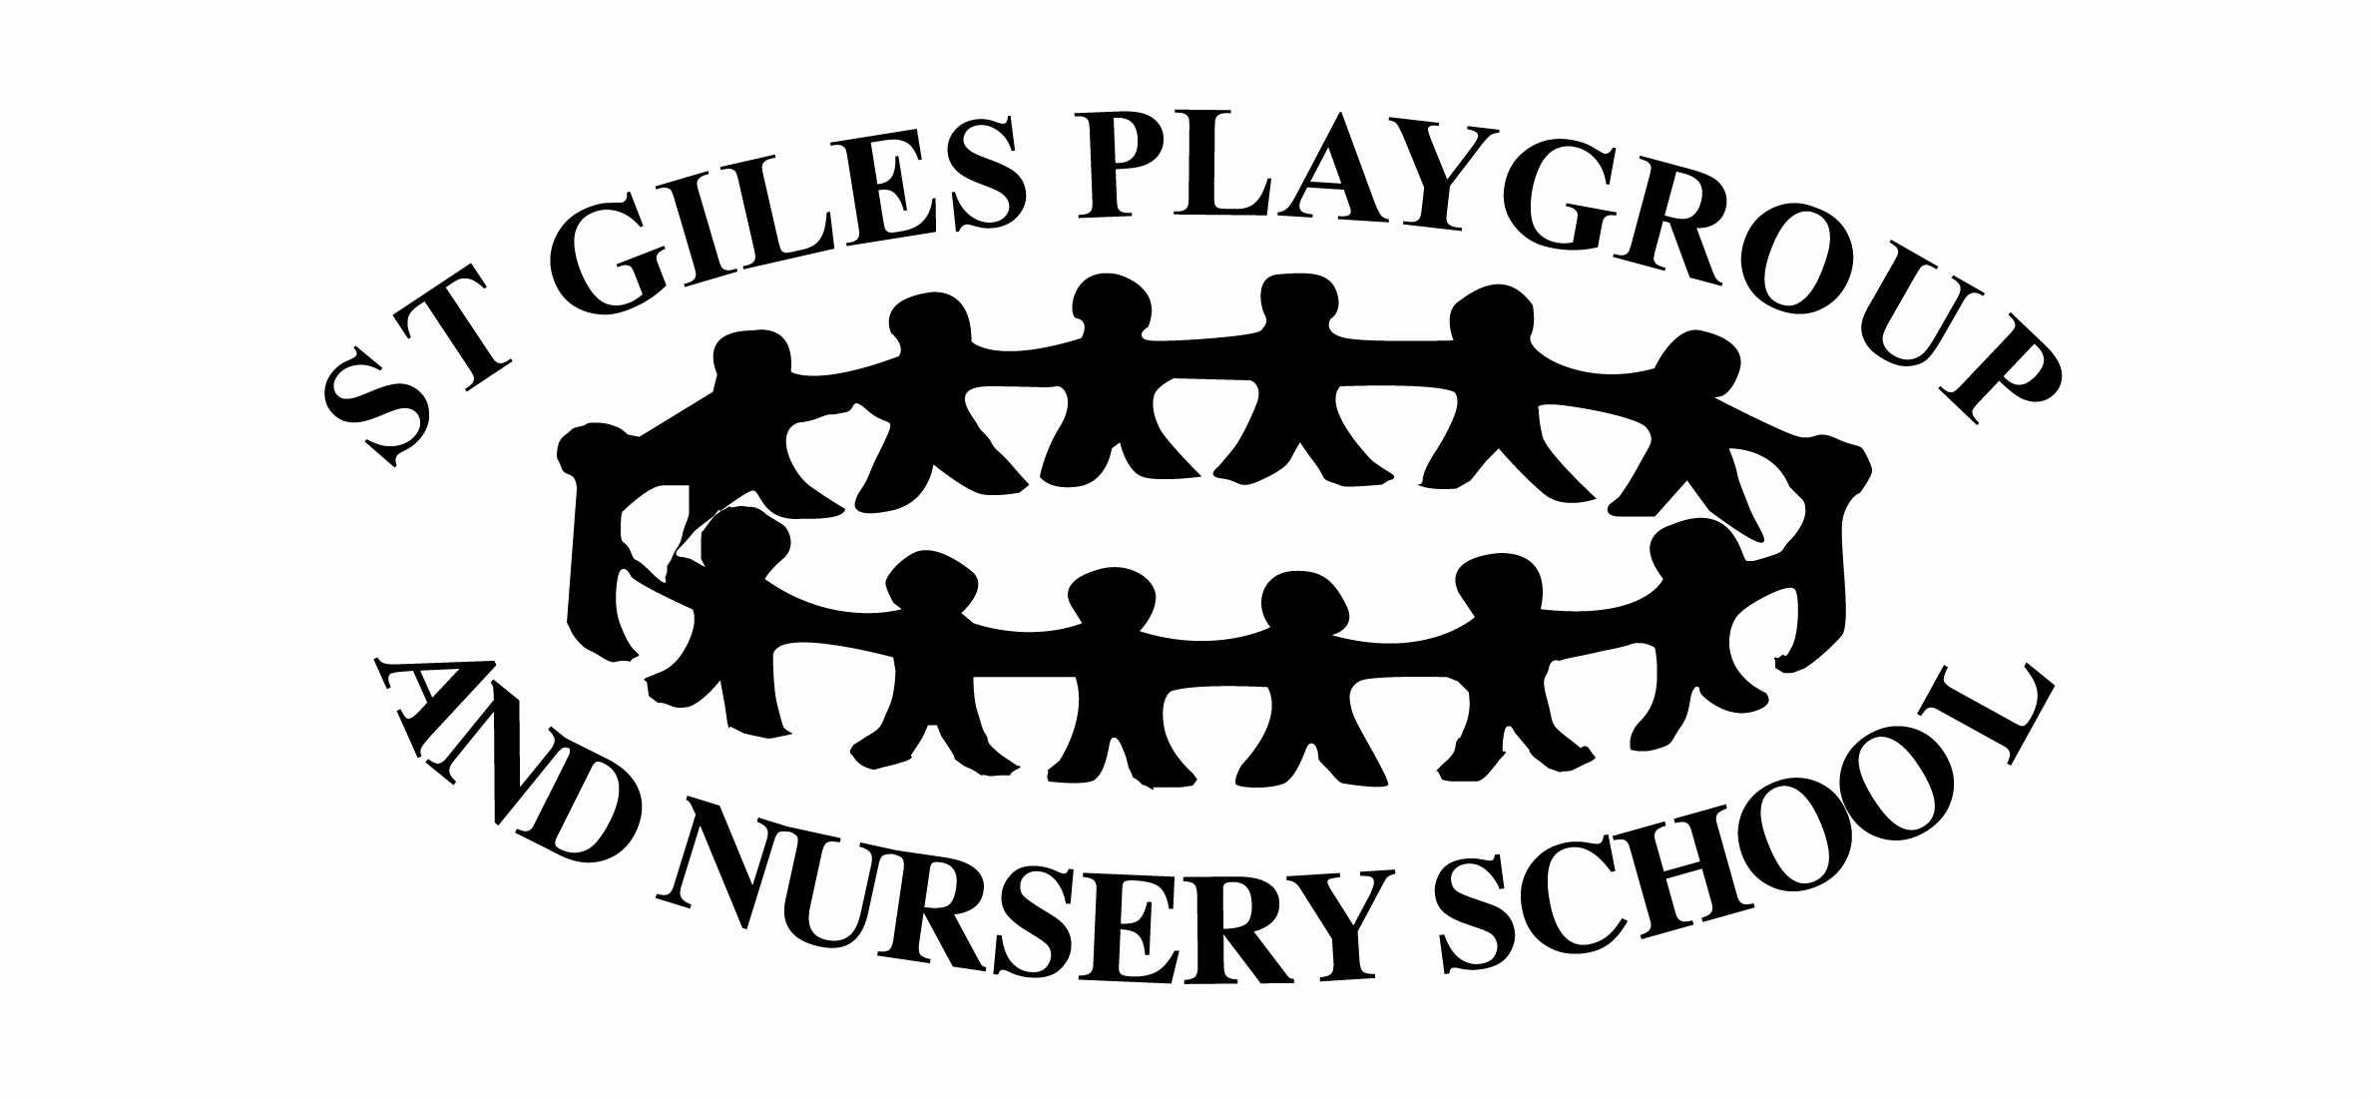
Policy and Procedure for September 2020 – Covid 19

Statement of Intent
The aim of this policy is to provide detailed information on the steps we are taking as a setting to protect the safety and wellbeing of the children and is an update of our June 1st policy, to reflect updates in Government guidance.
It will detail the risks identified and the ways in which these will be managed, addressed and minimised.
It will outline the new procedures and changes to daily routines required. Everyone is required to comply with these without exception in order for us to operate in as safe a way as possible under these challenging circumstances.
This policy is informed by the following documents:
Actions for early years and childcare providers during the coronavirus outbreak - https://www.gov.uk/government/publications/coronavirus-covid-19-early-years-and-childcare-closures
Coronavirus (COVID-19): implementing protective measures in education and childcare settings –
https://www.gov.uk/government/publications/coronavirus-covid-19-implementing-protective-measures-in-education-and-childcare-settings/coronavirus-covid-19-implementing-protective-measures-in-education-and-childcare-settings

We will return to normal group sizes and session time with an increase in the frequency of handwashing and cleaning of toys and resources, “high traffic” areas, tables and chairs, toilets and door handles.
Resources which cannot easily be cleaned with antibac spray or wipes will be rotated. We will have a different set for each day of the week. This will include (but not be limited to) books, dressing up clothes and soft toys, dolls and accessories.
Children attending other settings – important
In order to minimise the risk of infection, the Government guidelines state that children should attend only one setting where possible. We realise, though, that our opening hours are not long enough for some working families. Therefore, children may attend St Giles Playgroup AND a childminder. Children may not attend St Giles Playgroup AND another preschool/nursery.

Before each session

Staff will arrive at 8.00.
All tables, chairs, door handles and toilets will be thoroughly cleaned.
The portable sink will be thoroughly cleaned and filled with warm water. It will be placed outside the entrance gates to the outdoor area. A folding table will be cleaned and placed next to the sink. A box of hand towels and a soap dispenser will be placed on the table with a bucket underneath.
2 clean plastic boxes will be wiped with antibac and placed on the table ready for the children’s bags and another plastic box (also wiped with antibac) will be placed alongside ready for the pre-prepared snacks.
The lunch trolley will be cleaned with antibac spray and wheeled out next to the table.
The accident/injury folder, prescribed medication folder and any other forms for signing will be placed near the doors to the outside area so that the staff member can easily access them when the gate is opened.
We will use the red and blue foam mats instead of carpets (with the exception of the “bug mat” which will be sprayed regularly and at the beginning and end of each session with disinfectant spray) These will be cleaned and laid out.
The usual daily risk assessment will be carried out.

Before drop-off (for Parents and Carers)
Please do not send your child to Playgroup if they are unwell in any way.
Please do not send your child to Playgroup if you have given them Calpol in the past 24 hours.
If your child develops any symptoms of Coronavirus it is vital that Government guidelines are followed – the child with symptoms is to isolate for 10 days and members of their household must isolate for 14 days (please see separate policy on Covid-19 Symptoms and Infection Control)
Please let us know as soon as possible if anyone in your household develops symptoms of coronavirus.
Snacks (fruit/vegetables/breadsticks) must be sent pre-prepared and ready for your child to eat in a named, disposable food bag. Please do not send containers that you want us to return to you.
Children’s belongings (change of clothes, nappies, wipes, suncream) must be sent in a labelled bag. During this time, we will not have spares available so please make sure you send everything your child will need for the session.
Lunchboxes will be required for children attending all day or an afternoon session – our usual lunchbox policy will apply – no nuts or products made from or containing nuts, no sweets, no fizzy or sugary drinks.
Lunchboxes should be plastic as the fabric ones cannot easily be wiped clean and disinfected.
Please send children in short sleeved tops with a jacket for use outside and a sun hat. These items can be placed in their bags. Short sleeves make it much easier to wash hands regularly and reduce the risk of infection from germs on clothing.
Please do not bring toys or other items from home. Dummies can be sent as comforters if necessary but this is the only exception we are able to make.
Please apply suncream before you arrive at Playgroup. We have a supply in the setting which we will use to “top up” after lunch. If you would prefer to supply your own, please supply a bottle clearly labelled with your child’s name for us to keep safely in the cupboard.

Drop-off time

Please arrive promptly at 9 and no later than 9.20 (12 and no later than 12.10 for the afternoon session)
Please observe 2m social distance rules.
Children attending a morning or full day will enter through the gates to the playground and the staff will be outside to greet them. Children attending an afternoon session will enter through the usual door once all of the morning children have left.
Morning/all day - please place your child’s bag and snack in the relevant boxes and their lunchbox on the trolley and then help your child to thoroughly wash their hands at the portable sink and bring your child to the gate where staff will be waiting.
Afternoon session – a member of staff will wear gloves and carry your child’s belongings in to playgroup. The staff member will then accompany your child to wash their hands before entering the playgroup hall.
Parents/carers will not be allowed inside the building except in an emergency.
If your child will not walk in to playgroup willingly, please bring them in a buggy. The buggy can then be wheeled to the gate/door after handwashing and the staff member will unstrap the child and carry them through to the playground where they will be comforted and settled by a member of staff. Please maintain the 2m social distance rule during this process for your own protection and that of the staff member.
New starters are welcome to join their children in the playground but must maintain social distancing from staff and other families and avoid contact with toys and resources where possible.
At 9.40, staff will take all of the children inside and parents will be required to leave.
Once all children are in, registered and settled, a staff member will wear gloves and carry the snack box, bag box and lunch trolley inside.
The portable sink will be cleaned, wheeled into the kitchen and refilled with warm water and then placed next to the snack table with a fresh supply of hand towels. The soap dispenser will be cleaned and placed next to it.
The box of children’s bags will be placed on the tables just inside the hall doors and the box of snacks will be placed on the counter between the kitchen and the hall. The lunch trolley will stay in the corridor.

During the session

The children will not be expected to practice social distancing. Adults should attempt to do so from each other as far as possible.
Gloves and masks will be made available for staff use if required.
One member of staff will be on cleaning duty for the session.
Tables, chairs, door handles, the portable sink unit and toys will be cleaned frequently throughout the session
A jug of water and plastic cups will be available for the children to use. The staff member on cleaning duty must be extra vigilant in this area and the jug should be swapped for a fresh one every 30 minutes and the plastic cups replaced with fresh ones at the same time.
Children must wash their hands before picking up the jug and their used cups must be placed into the washing up bowl immediately after use.
If a child hurts themselves, any member of staff can administer first aid and comfort the child in the usual way. Gloves will be available as usual for staff members to use. Instead of asking parents to sign accident forms at the end of the session, a photograph will be taken and emailed to parents.
Every 30 minutes, the bell will ring and the staff and children will wash their hands. We will split between the sinks in the toilets and the portable sink in the hall to make this manageable.
Once everyone is back in the hall, the staff member on cleaning duty will clean all sinks and taps.
When a child has used the toilet, the seat and the flush handle will be cleaned immediately afterwards and the child will wash their hands as usual with adult support.
Snack bar will not operate in the usual way. Instead, at 10.30, all staff and children will wash their hands with adult support for the children and then sit at a table (no more than 5 children at each table)
An adult will then hand out the individual pre prepared snacks and offer a choice of milk or water.
One member of staff will sit at each table to supervise and support the children as needed.
The children must stay at the table until everyone has finished. Leftover food will then be disposed of and cups and jugs will be taken to the kitchen by the staff member on cleaning duty. Everyone will then wash their hands again. The children can then return to their play.
Suncream will be applied to every child before we go outside after lunch on sunny days. Please ensure you provide a sun hat clearly labelled with your child’s name. Under these circumstances, we will not be supplying playgroup hats for children who have forgotten. On hot, sunny days we cannot allow children to play outside without a hat and this may mean that you will have to come back to drop one off or collect your child until you can supply one.
There will be no sand available but we will provide a variety of other resources and will cover all areas of the EYFS curriculum as far as we are safely able to.
A fresh batch of play dough will be made for the start of each session and disposed off at the end of that session. Play dough tools will be thoroughly cleaned in the dishwasher between uses. Play dough mats will be wiped with antibac between uses.
A fresh tray of pencils will be available for each session. At the end of the session, it will be cleaned with antibac and stored for 72 hours before being used again.
The staff member on cleaning duty will clean the paintbrushes and paint pots every hour, replacing with fresh ones.
We will spend as much time outside as possible. A pack of antibac wipes will be stored on a high shelf in the shed so that bike and scooter handles, seat, slides and climbing equipment can be wiped regularly and between uses.
We will add bodywash to the water in the water tray. This will be refreshed throughout the session.
At 11.40, the bell will ring and children will gather for a song and a short story before all washing hands. Children going home will line up in the corridor with staff supervision and support.
The portable sink will be cleaned and wheeled outside the door. The hand soap and hand sanitiser gel bottles will be wiped and placed on the table outside the door with a fresh supply of hand towels.

Children staying for lunch will find their places at the tables and staff will bring their lunch boxes to them.
One member of staff will sit and eat with the children at each table. Once everyone has finished, everyone will wash their hands again before returning to play. The member of staff on cleaning duty will dispose of left over food and rubbish and wipe down all lunchboxes before replacing them on the trolley and wheeling it outside ready for collection at the end of the session.
Pick up time
Please arrive promptly at the end of the session to collect your children.
Please wait in line, observing 2m social distancing rules.
Children will come out of the usual door on the side of the building adjacent to the gates to the playground.
Where possible, one adult should come to collect each child.
The adult at the door will send the children out one at a time. The collecting adult should help the child to wash their hands at the portable sink and collect their belongings.
If you need to collect your child before the end of the session, please let a member of staff know. We will ensure that they wash their hands and bring their belongings to the door.
After the session
Staff will clean tables, chairs, door handles, toilets, sinks and resources and their boxes.
The foam floor mats will be cleaned with antibac spray and the floor will be swept and mopped.
The mop heads will then be left to soak in a bleach and hot water solution overnight.
Used tea towels and dressing up clothes will be taken home by a member of staff in separate bags and washed at 60 degrees, ready to return the next day.
Washing up will be completed and put away and the kitchen surfaces, sinks and taps will be cleaned and the floor swept and mopped.
Staff will then wash their hands before leaving.

