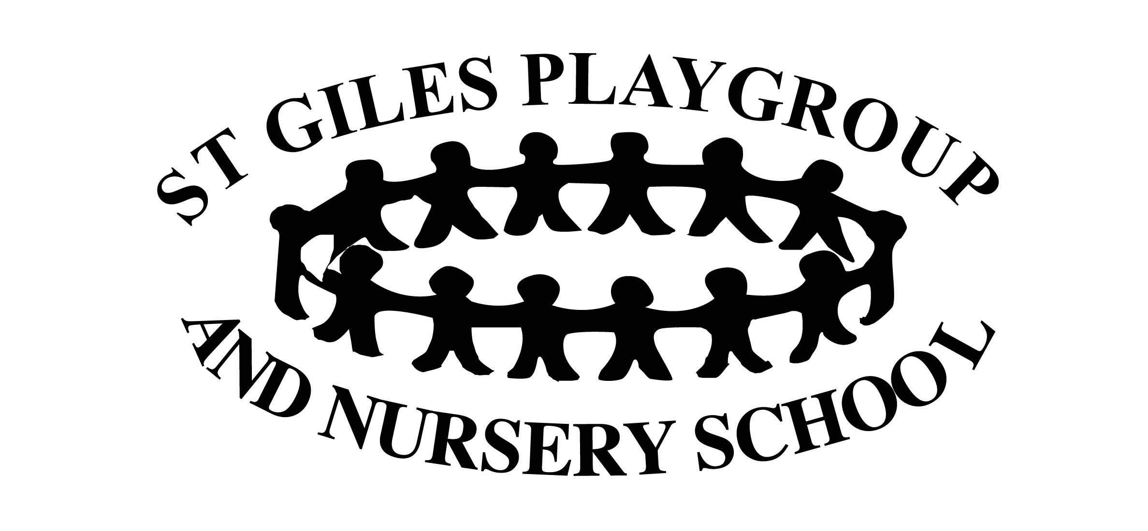
Equality, Inclusion Valuing Diversity Policy

Statement of intent.

To ensure that our service is fully inclusive in meeting the needs of all children, particularly those that arise from their ethnic heritage, social and economic background, gender or level of ability.

Aim

We aim to

- Provide a secure and accessible environment in which every child can flourish and in which all contributions are considered and valued.
- Include and value the contribution of all families to our understanding of equality and diversity.
- Provide positive, non-stereo-typing information about gender roles, diverse ethnic and cultural groups and differing levels of ability.
- Improve our knowledge and understanding of issues of non-discriminatory practice, promoting equality and valuing diversity.
- Make inclusion a thread that runs through all of the activities in the setting.

Method

In order to meet our legal duties, promote equality and inclusion in our setting and value diversity, we follow these procedures:

Admissions
- Our setting is open to all members of the community
- We advertise our service widely
- We reflect the diversity of members of our society in our publicity and promotional materials
- We provide information in clear, concise language, whether in spoken or written form
- We will translate written information into a different language if required
- We base our admissions policy on a fair system
- We ensure that all parents are made aware of our equality and diversity policy and all other relevant policies which are available on the Playgroup website
- We will not discriminate against a child or their family or prevent entry to our setting on the basis of colour, gender, ethnicity, religion, level of ability or socio-economic background.
- Staff deal sensitively and discretely with the personal care of children, ensuring their safety and wellbeing in line with our personal care and safeguarding policies.
- We take steps to ensure that all individuals can participate in a meaningful way in the services offered by the setting and in the curriculum offered
- We take action against any discriminatory behaviour by staff or parents. Displaying of openly discriminatory and possibly offensive materials, name calling or threatening behaviour or language are unacceptable on or around the premises and will be dealt with in the strongest manner.

Employment

- Posts are advertised and all applicants are judged against explicit and clear criteria
- Applicants are welcome from all backgrounds and posts are open to all
- We may use exemption clauses in relevant legislation to enable the service to best meet the needs of the community
- The applicant who best meets the criteria is offered the post, subject to references and DBS checks. This ensures fairness in the selection process.
- All job descriptions include a commitment to valuing equality and recognising and respecting diversity as part of their specifications
- We monitor our application process to ensure that it is fair and accessible.

Training

- We seek out training opportunities for staff and volunteers to enable them to develop anti-discriminatory and inclusive practices and to help all children to achieve their full potential.
- We ensure staff are confident and fully trained in administering relevant medicines and performing personal care.
- We review our practices to ensure that we are fully implementing our policy for promoting equality, valuing diversity and inclusion.

Curriculum and environment

The curriculum offered in the setting encourages children to develop positive attitudes about themselves as well as to people who are different from themselves.
It encourages children to empathise with others and to begin to develop the skills of critical thinking.
The environment should be accessible to all service users and visitors. Reasonable adjustments will be made to ensure that this is the case.
We do this by:

- Developing positive relationships with families through the key person system, supporting children’s personal development and learning
- Making children feel valued and positive about themselves
- Undertaking regular audits to ensure that the setting is accessible to all children
- Making adjustments to the environment and resources to accommodate the needs of all individual children
- Making appropriate provisions within the curriculum to ensure each child receives the widest possible opportunity to develop their skills and abilities
- Positively reflecting the widest possible range of communities in the choices of resources
- Avoiding stereotypes or derogatory images in the selection of books and other visual materials
- Celebrating a wide range of festivals
- Creating an environment of mutual respect and tolerance
- Differentiating the curriculum to meet the needs of every individual child
- Helping children to understand that discriminatory behaviour and language are hurtful and unacceptable.
- Ensuring that children learning English as an additional language have full access to the curriculum and are effectively supported in their learning
- Ensuring that children speaking languages other than English are supported in the maintenance and development of their home languages

Valuing diversity in families

- We welcome the diversity of family lifestyles
- We encourage children to contribute and share stories of their daily lives
- We encourage the participation and engagement of families within the setting
- We work to develop the means to communicate effectively with families whose first language is not English
- We offer a flexible payment system for families of differing means and offer information regarding sources of financial support
- We respect families’ differences and privacy and maintain confidentiality following procedures outlined in our confidentiality policy.

Food

- We work in partnership with parents to ensure that the medical, cultural and dietary needs of children are met
- We help children to learn about a range of food and of cultural approaches to mealtimes and eating and to respect the differences among them

Meetings

- Information about meetings is communicated in a variety of ways – written, verbal and in translation where necessary to ensure that all parents have information and access
- Committee meetings are open to all parents to ensure that all families who wish to attend can be included in the running of the setting.

Monitoring and reviewing

- Our policies and procedures are reviewed annually
- We provide a complaints procedure

This policy was adopted at a meeting of | St Giles Playgroup & Nursery
Held on (date) | 13 April 2020
Signed on behalf of the Management Committee/Proprietor
Role of signatory (e.g. chairperson etc.)
This policy was reviewed on |  | (date)
continue as necessary |  | (date)

