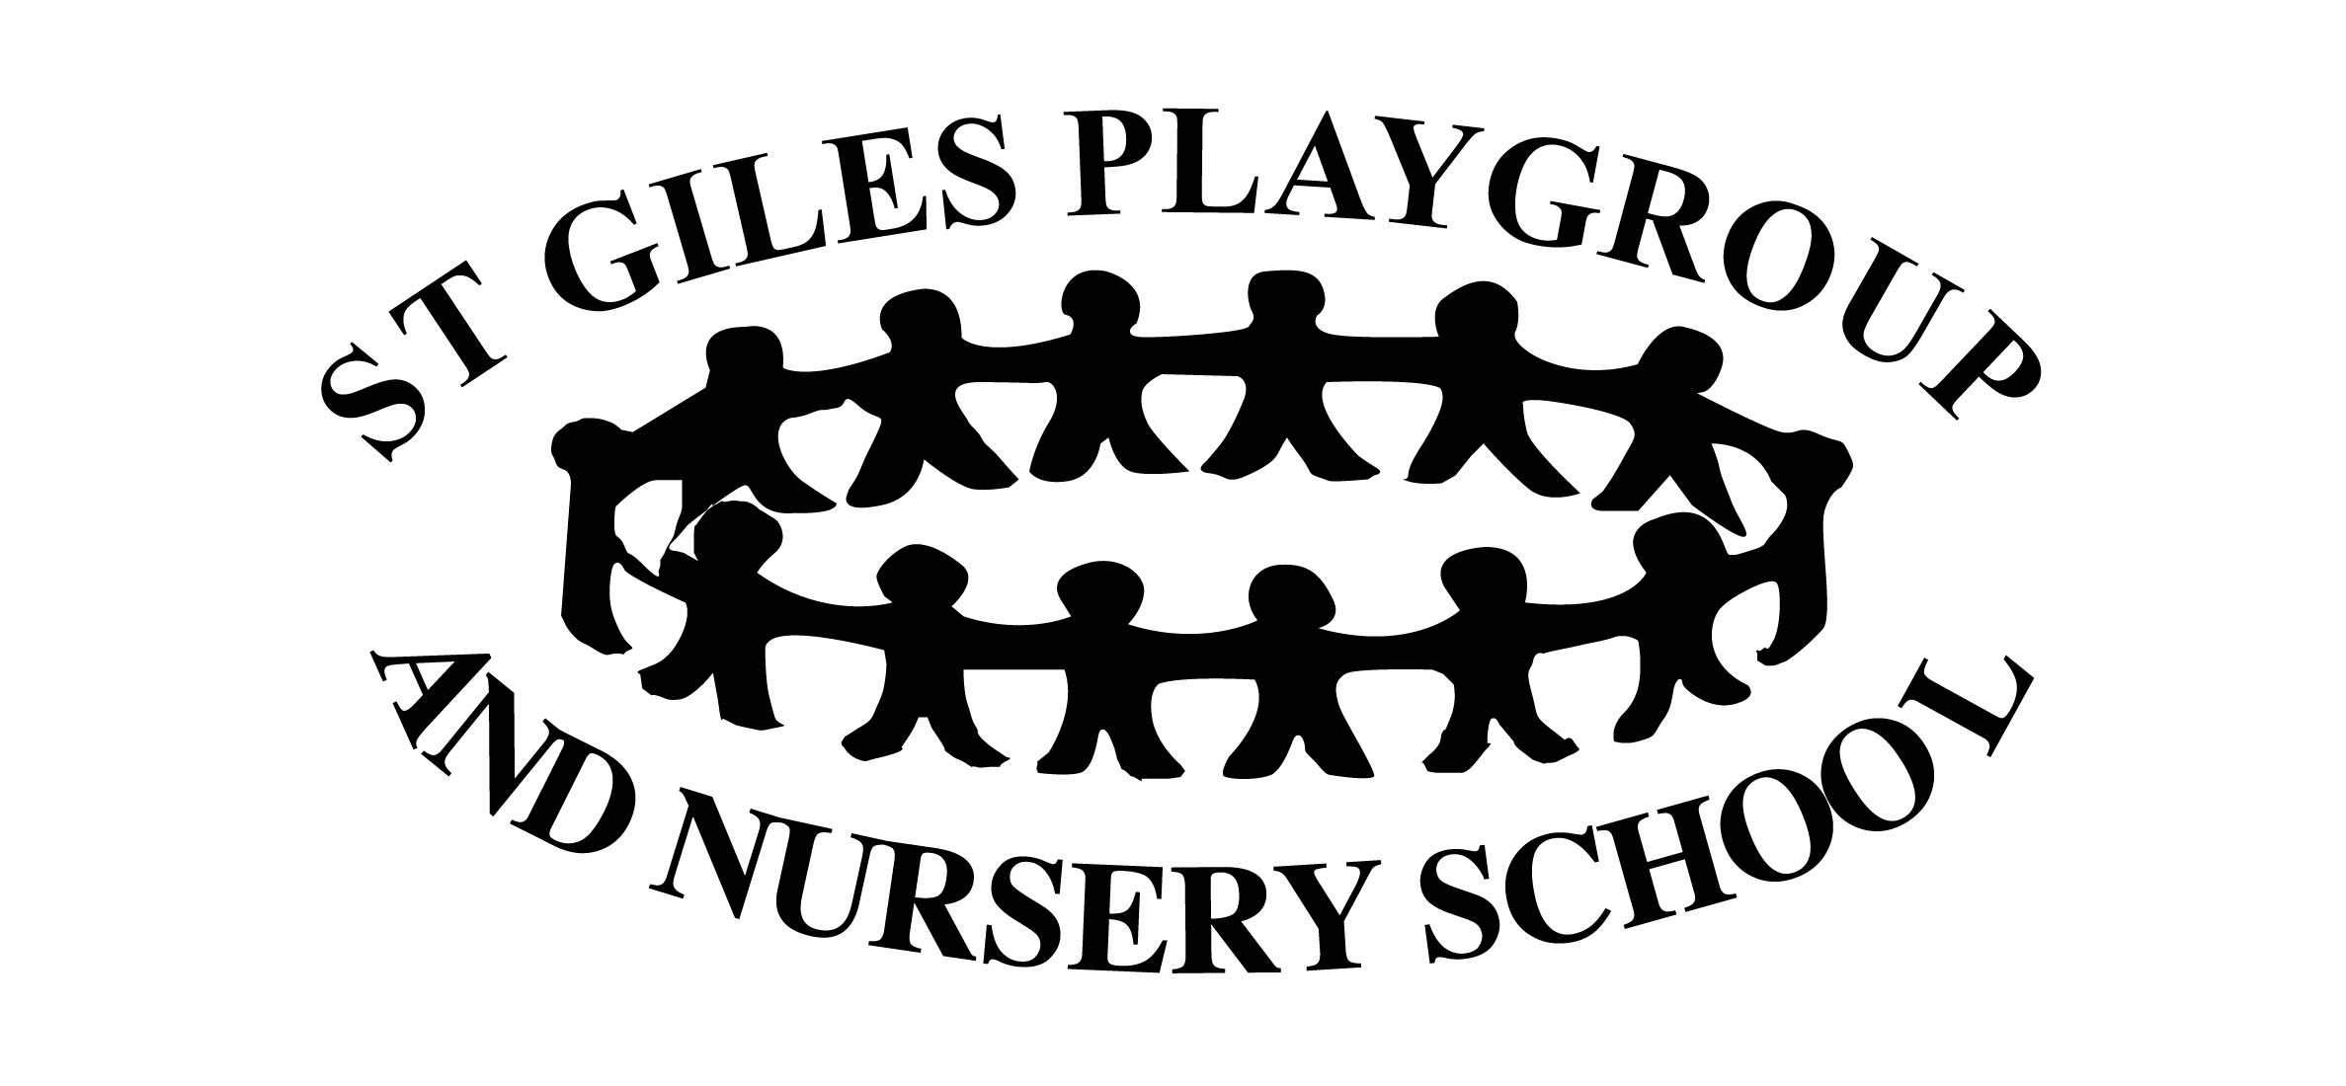
Policy on use of Mobile Phones in the setting

Statement of intent.

To make sure that all staff, committee members, parents and visitors are aware of the need to protect our children from harm, and to have a clear understanding of what constitutes the misuse of a mobile phone.

Setting Mobile Phone use.
- The playgroup has its own mobile phone which is switched on at 8am and switched off at the end of the session when all the children have been collected.
- The phone is kept on the table and locked away in the cupboard in out of session hours.
- The phone is clearly labelled, and staff are made aware that this is the work mobile.
- The work mobile should not be used for personal calls.
- The work mobile is for calls and texts only.
- The playgroup number can be given to the schools of staff member’s children to be used in an emergency during their working session.
- The phone should be used in the hall, but due to noise levels in the hall sometimes, it can be taken into the kitchen or the corridor to be used.
- The work mobile will be used on all outings out of the setting, for emergency/ nursery calls.

Staff Personal mobiles.
- Staff use of personal mobiles is limited to times that the children are not in playgroup.
- Mobiles should be kept in handbags and then put out of reach and not kept on their person.
- Staff are responsible for their own mobile phone security, and no liability will be accepted by the setting for loss or damage.
- Committee members and parents should be made aware that phones should not be used in the hall whilst the children are in there.
- No photos, video or audio recordings can be made without consent from the setting.
- Staff should not use their own personal mobiles to contact parents except in the event of an emergency.
- Individuals who bring phones in the setting should make sure they don’t hold illegal or inappropriate content.
- Mobiles may only be used in child free areas of the setting.
- Mobiles must never be used to take photographs of any of the children, the setting or the staff while at work.
This policy was adopted at a meeting of | St Giles Playgroup & Nursery
Held on (date) | 13 April 2020
Signed on behalf of the Management Committee/Proprietor
Role of signatory (e.g. chairperson etc.)
This policy was reviewed on |  | (date)
continue as necessary |  | (date)

