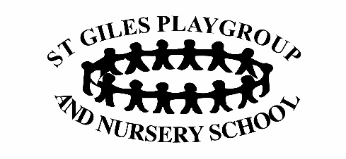
Whistleblowing Policy and Guidelines
Statement
It is our intention that the staff working at St Giles Playgroup feel confident in coming forward and reporting any issues and concerns that they may have regarding any aspect of the setting.
This policy is intended to encourage staff to raise concerns within the setting on any matters regarding poor practice at work. Staff are responsible for the safety and wellbeing of the children and this is a priority over loyalty towards colleagues.
Aims
Ensure staff understand their responsibilities and feel confident in raising concerns at the earliest opportunity.
Provide avenues for staff to raise concerns and receive feedback on any action taken.
Ensure concerns are appropriately investigated.
Ensure staff receive a response and are aware of how to pursue their concerns if they are not satisfied with the response received.
Reassure staff that they will be protected from reprisals or victimisation if they have made any disclosures in good faith.
Confidentiality
The Manager and Committee Chair will do their best to protect a person’s identity when a concern is raised. However, in some circumstances, it is necessary for identities to be revealed.
Having raised concerns, the Manager/Chair will expect the complainant not to talk to a third party about them either inside or outside of the setting.
What should be reported?
The inappropriate treatment or care of a child.
Any breach in the behaviour of the Manager, staff or volunteer.
Discrimination of any kind.
Concerns that could impact on the health or wellbeing of the children or the adults.

How to raise a concern
A concern can be raised by any staff member to the Manager, Deputy or Chair as appropriate.
The nature of the concern should be discussed with the history and background of the concerns giving as much detail as possible and including names, dates and places.
The concern should be put in writing.
There is no expectation that staff prove beyond doubt the truth of their suspicion. However, they will need to demonstrate that they are acting in good faith and that there are reasonable grounds for their concern.
All staff members will be treated fairly and with discretion.
Staff should not:
Investigate the matter themselves or attempt to.
Alert those suspected of being involved.
Approach or accuse individuals.
Tell anyone except the designated persons.
Concerns will be dealt with in the following way:
The concerns will be investigated by the Manager and/or the Chair.
If appropriate, it will be referred to the LADO and the Safeguarding Children’s Partnership and may be the subject of an independent inquiry.
Within ten working days, the member of staff will receive in writing:
Acknowledgement that the concern has been received.
An indication of how the Playgroup will deal with the matter.
The Manager/Chair will:
Supply the member of staff with support mechanisms as appropriate.
Inform the staff member about any further investigation. If none is to take place, an explanation will be provided.

If the staff member is not satisfied with the outcome, they may express their concerns directly to OFSTED’s whistleblowing helpline on 0300 123 1231. More information is available at www.ofsted.gov.uk/contact-us/how-complain

Signed by Manager…………………………………………………………….
Date…………………………………………………………………….
Review date…………………………………………………………

